EST 1973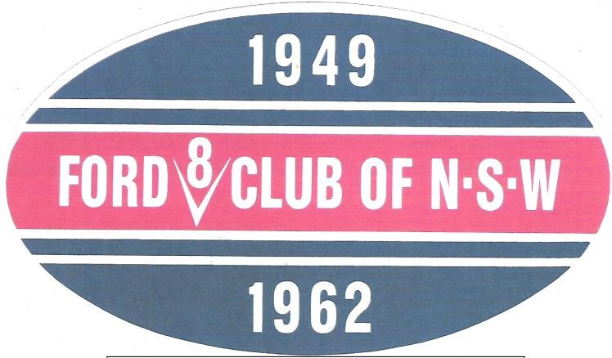
YOU ARE INVITED TO APPLY FOR RENEWAL OF MEMBERSHIP IN THE CLUB
RETURN TO.
1949-1962 FORD V8 CLUB OF NSW
48 CURRAWANG ST
CONCORD WEST 2138
RAY 0408251149 H 0297430847
pres@fordv8club.com
Or
MEMBERSHIP CO-ORDINATOR
4 GUM ST
RIVERSTONE 2765
MEMBERSHIP RENEWAL NOTICE
2017/2018 Membership Subscription of $30 NOW OVER DUE.
Any problems please call no’s above
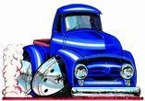Renewals close 30/8/2017

$30.00/1YEAR $60.00/2YEARS
MAKE PAYMENT OUT TO THE 1949- 1962 FORD V8 CLUB OF NSW
NAME
ADDRESS
CAR REGO NO;
EMAIL PHONE NO

