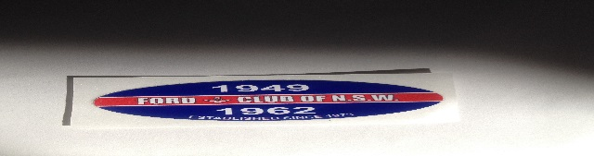
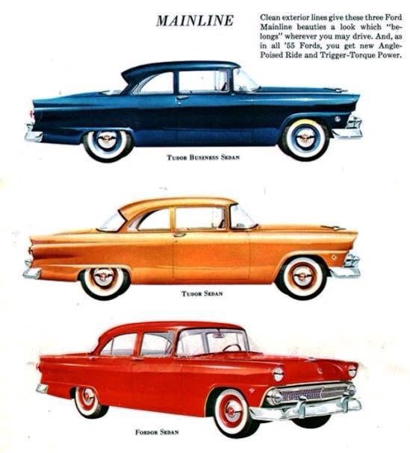
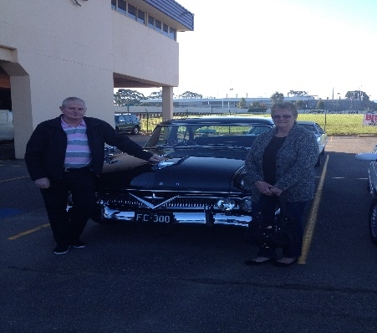
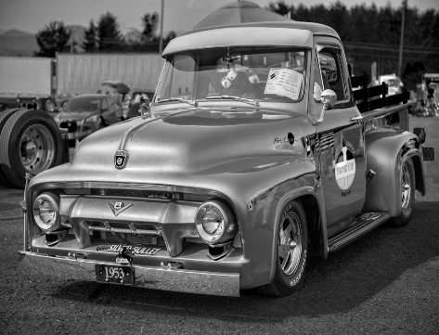
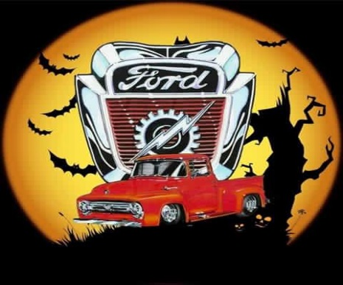
HI MEMBERS
NEW & OLD WELCOME
THE PICS ON THIS PAGE IS WHAT THIS CLUB IS ALL ABOUT, PEOPLE WITH A PASSION FOR FORD CARS & TRUCKS IT’S YOUR CLUB WE HAVE SET MOST OF THE RUNS THERE ARE A FEW TO DO PUT ON YOUR THINKING CAPS IT CAN BE ANY WHERE MOST MEMBERS WANT BACK TO BASICS . A NICE RUN LUNCH OR BBQ NOT ALL SHOWS, WE HAVE MOVED THE RUNS BACK TO THE 3RD SUNDAY OF THE MONTH BAR MAJOR EVENTS THE AGM HAS BEEN MOVED BACK TO 11 September 2016 TO GIVE EVERYONE TIME TO TALK ON THE UP COMING RUNS EG COMMITTEE MEMBERS HELPERS ETC, SO PUT YOUR IDEARS ON THE PAGE WITH THIS, BIG OR SMALL.
CLUB PLATES
SOME MEMBERS ASK WHY THEY DON’T SEE SOME OF THE MEMBERS AND THERE CARS THAT ARE ON CLUB PLATES. THERE ARE RULES THAT GO WITH THEM 3 RUNS & THE AGM. OTHER CLUBS HAVE STARTED CHARGING FEES OF $200 a CAR, PER YEAR ON MEMBERS THAT HAVE CLUB PLATES THEY STILL GET CHEAP REGO BETTER THAN $1000.00 A YEAR.

THERE ARE TWO TYPES OF CLUB PLATES
THE H PLATE. CLUB RUNS, LISTED RUNS WITH OTHER CLUBS &INVITES MAINTENANCE & TESTING WHICH YOU MUST RING THE REGISTRAR TO GET A RUN NUMBER, IF YOU DON’T AND YOU GET BUSTED YOU ARE ON YOUR OWN THE CLUB WILL NOT HELP AND YOU PUT THE CLUB IN A BAD SPOT. SO IF YOU SEE A CLUB MEMBER DRIVING AROUND AND YOU THINK THEY ARE DOING WRONG, A CALL TO ME AND I WILL CHECK WITH IAN EDDLESTON THE REGISTRAR. IT’S NOT HIS JOB TO COVER FOR ANYONE JUST RECORD MOVMENTS FOR THE CLUB.SO WE ARE GOOD WITH THE RMS.

TYPE 2. CLUB PLATES LOG BOOK TRIAL 2YEARS STARTED LATE 2015
60 MOVMENTS +CLUB RUNS, MAINTENANCE & TESTING
ON THIS ONE YOU MUST RECORD EACH ONE ON YOUR LOG SHEET
ITS YOU HOW IS RESPONABLE FOR THIS ONE, NOT THE CLUB. BUT YOU ARE A MEMBER OF THE CLUB SO DO THE RIGHT THING. OR WE LOSE IT.
THEY MAY BE SOME GREY AREAS? IF IN DOUGHT CALL RMS ITS THERE BABY
THEY MAKE THE RULES WE FOLLOW THEM, NOT HEAR SAY.GET IT IN WRITING.
MODIFIED CLUB PLATES
IS THE NEXT ONE COMING THEY ARE WORKING IT OUT NO NEWS AS YET.
THE SYSTEM IS THERE FOR ALL TO INJOY BUT THERE IS RULES!!

AFD IS TICKET ENTRY ONLY CALL ME TO BOOK YOUR SPOT
CMC DAY TICKET ONLY COST $20.00 CALL TO BOOK
ALL INFO IN THIS NOTE IS NOT AT ANYONE, ITS JUST INFO THAT HAS END UP ON MY DESK, SO TALK TO YOUR CLUB MEMBERS WHEN YOU ARE ON A RUN IT’S YOUR CLUB. LIFE IS TOO SHORT FOR BS. I JUST WANT TOO HAVE FUN CRUZIN ON THE BLACK TOP IN MY PICK UP. AND MIXING WITH GOOD PEOPLE
THAT’S IT SORRY IT’S LATE TAKES TIME TO GET ALL OF THIS OUT OF MY HEAD
PLANING A NEWS LETTER NEED STORYS & PICS FOR IT.
SEE U SOON
RAYZZ

